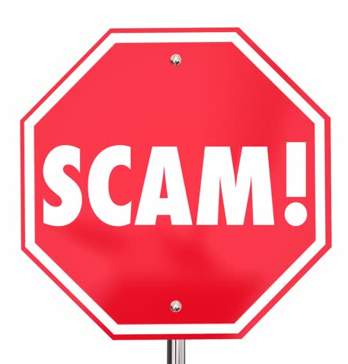
Scam Action Plan and Resource List
When I am not sure if something is a scam or not, I will contact:
- ______________________________________________
- ______________________________________________
- ______________________________________________

I can also contact:
- Adult Protective Services
- My bank: __________________________
- My local Department of Consumer Affairs
- I can go to my local bar association and legal aid office to get information about local consumer attorneys who can help me.
- I can make a report with the Federal Trade Commission by going to www.ftc.gov or by calling 1-877-FTC-HELP (1-877-382-4357)
- The Consumer Financial Protections Bureau to make a complaint about homeowner fraud, scammy debt collection practices, issues with money transfers: https://www.consumerfinance.gov/complaint/
- The Center for Medicaid and Medicare if I suspect I am a victim of Medicaid/Medicare fraud: (1-800-447-8477)
- www.Identitytheft.gov if I suspect identity theft
- I can make a complaint with the Better Business Bureau: https://www.bbb.org/consumer-complaints/file-a-complaint/get-started
- The AARP has more resources on their website: https://www.aarp.org/money/scams-fraud/
- Consumer Action has many educational materials: https://www.consumer-action.org/modules/articles/senior_scams

